**UJIAN TENGAH SEMESTER**

**“BAROKAH MINIMARKET”**



**OLEH :**

Meike Hardianti (18081010031)

**PARALEL A**

**DOSEN PENGAMPU :**

FAWWAZ ALI AKBAR, S.Kom., M.Kom.

NIP. 199203172018031002

**PROGRAM STUDI INFORMATIKA**

**FAKULTAS ILMU KOMPUTER**

**UNIVERSITAS PEMBANGUNAN NASIONAL “VETERAN”**

**JAWA TIMUR**

**2020**

**SOURCE CODE**

1. Conn.php

|  |
| --- |
| <?php  function connection() {    $dbServer = 'localhost';  $dbUser = 'root';  $dbPass = '';  $dbName = "UTS";  $conn = mysqli_connect($dbServer, $dbUser, $dbPass);  if(! $conn) {  die('Koneksi gagal : ' . mysqli_error());  }  mysqli_select_db($conn,$dbName);    return $conn;  } |

1. Index.php

|  |
| --- |
| <?php  include('conn.php');  ?>  <!DOCTYPE html>  <html>  <head>  <title>AYO</title>  <link rel="stylesheet" type="text/css" href="960.css">  </head>  <body>  <div class="container_12" style="background-image: url(foto1.JPG);">  <div class="foto">  <div style="text-align: center; font-size: 25px;">  <font color="brown"><H1>BAROKAH MINIMARKET</H1></font>  </div>  <button><a href="<?php echo "form.php"; ?>">Tambah Data</a></button>  <button><a href="<?php echo "search.php"; ?>">Cari Data</a></button>  <form action="filter_range.php" method="post">  <div class="td">  <table border="0px" cellpadding="5px" cellspacing="0px" class="text " style="font-weight: bold;">  <tr>  <td colspan="6" style="text-align: center;">Range Harga</td>  <tr>  <td>  <label for="min_harga">Min : </label>  <input type="text" name="min_harga" id="min_harga">  </td>  <td>  <label for="max_harga">Max : </label>  <input type="text" name="max_harga" id="max_harga">  </td>  <td>  <button type="submit" name="submitfilter">Filter</button>  </td>  </tr>  </tr>  </table>  </div>  <div style="text-align: center;">  <h1>DATA BARANG </h1></div>  <form method="POST" action="form.php">  <table border="1" style="margin-left: auto; margin-right: auto; font-size: 20px; text-align: center; font-weight: bold;">  <tr>  <th>SKU</th>  <th>NAMA BARANG</th>  <th>KATEGORI</th>  <th>JUMLAH STOK</th>  <th>HARGA SATUAN</th>  <th>ACTION</th>  </tr>  <tbody>  <?php  $query = "SELECT * FROM barang";  $result = mysqli_query(connection(),$query); ?>  <?php while($data = mysqli_fetch_array($result)): ?>  <tr>  <td><?php echo $data['sku']; ?></td>  <td><?php echo $data['nama_barang']; ?></td>  <td><?php echo $data['kategori']; ?></td>  <td><?php echo $data['jumlah_stok']; ?></td>  <td><?php echo $data['harga_satuan']; ?></td>  <td>  <a href="<?php echo "update.php?sku=".$data['sku']; ?>" class="btn btn-outline-warning btn-sm"> Update</a> &nbsp;&nbsp;  <a href="<?php echo "delete.php?sku=".$data['sku']; ?>" class="btn btn-outline-warning btn-sm"> Delete</a> <br>  </td>  </tr>  <?php endwhile ?>  </tbody>  </table>  </form>  </div>  </div>  </body>  </html> |

1. Form.php

|  |
| --- |
| <?php  include('conn.php');  if ($_SERVER['REQUEST_METHOD'] === 'POST') {  $sku = $_POST['sku'];  $nama_barang = $_POST['nama_barang'];  $kategori = $_POST['kategori'];  $jumlah_stok = $_POST['jumlah_stok'];  $harga_satuan = $_POST['harga_satuan'];  $query = "INSERT INTO barang(sku, nama_barang, kategori, jumlah_stok, harga_satuan) VALUES('$sku', '$nama_barang', '$kategori', '$jumlah_stok', '$harga_satuan')";  $result = mysqli_query(connection(), $query);  }  ?>  <!DOCTYPE html>  <html>  <head>  <title>ADD DATA</title>  <link rel="stylesheet" type="text/css" href="960.css">  </head>  <body>  <div class="container_12" style="background-image: url(foto.JPG); margin: 200px; height: 200px;">  <div style="text-align: center;">  <font color="grey"><h1>INPUT DATA BARANG</h1></font>  </div>  <form action="form.php" method="POST">  <table >  <tr>  <td>  <label>SKU </label>  </td>  <td>  : <input type="text" name="sku">  </td>  </tr>  <tr>  <td>  <label>NAMA BARANG</label>  </td>  <td>  : <input type="text" name="nama_barang">  </td>  </tr>  <tr>  <td>  <label>KATEGORI</label>  </td>  <td>  : <select type="text" name="kategori">  <option>--- Pilih Salah satu ---</option>  <option>Makanan</option>  <option>Minuman</option>  <option>ATK</option>  </select>  </td>  </tr>  <tr>  <td>  <label>JUMLAH STOK</label>  </td>  <td>  : <input type="text" name="jumlah_stok">  </td>  </tr>  <tr>  <td>  <label>HARGA SATUAN</label>  </td>  <td>  : <input type="text" name="harga_satuan">  </td>  </tr>  </table> <input type="submit" name="submit" value="Simpan">  <button><a href="<?php echo "index.php"; ?>">Back</a></button>  </form>  </body>  </html> |

1. Update.php

|  |
| --- |
| <?php  include('conn.php');  if ($_SERVER['REQUEST_METHOD'] === 'POST') {  $sku = $_POST['sku'];  $nama_barang = $_POST['nama_barang'];  $kategori = $_POST['kategori'];  $jumlah_stok = $_POST['jumlah_stok'];  $harga_satuan = $_POST['harga_satuan'];  $query = "UPDATE barang SET sku = '$sku', nama_barang='$nama_barang', kategori='$kategori', jumlah_stok='$jumlah_stok', harga_satuan='$harga_satuan' WHERE sku='$sku' ";  $result = mysqli_query(connection(), $query);  header("Location: http://localhost/MEIKE_UTS/");  }  if ($_SERVER['REQUEST_METHOD'] === 'GET') {  $sku = $_GET['sku'];  $query_get = "SELECT * FROM barang WHERE sku = '$sku'";  $result_get = mysqli_query(connection(), $query_get);  }  ?>  <!DOCTYPE html>  <html>  <head>  <title>UPDATE</title>  <link rel="stylesheet" type="text/css" href="960.css">  </head>  <body>  <div class="container_12" style="background-image: url(foto.JPG); margin: 200px; height: 200px;">  <h1>UPDATE DATA BARANG</h1>  <form action="update.php" method="POST">  <table>  <?php while ($data = mysqli_fetch_array($result_get)) : ?>  <tr>  <td>  <label>SKU </label>  </td>  <td>  : <input type="text" name="sku" value="<?php echo $data['sku']; ?>">  </td>  </tr>  <tr>  <td>  <label>NAMA BARANG</label>  </td>  <td>  : <input type="text" name="nama_barang" value="<?php echo $data['nama_barang']; ?>">  </td>  </tr>  <tr>  <td>  <label>KATEGORI</label>  </td>  <td>  : <select name="kategori">  <option value="">Pilih Salah Satu</option>  <option value="Makanan" <?php echo $data['kategori'] == 'Makanan' ? 'selected="selected"' : '' ?>> Makanan</option>  <option value="Minuman" <?php echo $data['kategori'] == 'Minuman' ? 'selected="selected"' : '' ?>> Minuman</option>  <option value="ATK" <?php echo $data['kategori'] == 'ATK' ? 'selected="selected"' : '' ?>>ATK</option>  </select>  </td>  </tr>  <tr>  <td>  <label>JUMLAH STOK</label>  </td>  <td>  : <input type="text" name="jumlah_stok" value="<?php echo $data['jumlah_stok']; ?>">  </td>  </tr>  <tr>  <td>  <label>HARGA SATUAN</label>  </td>  <td>  : <input type="text" name="harga_satuan" value="<?php echo $data['harga_satuan']; ?>">  </td>  </tr>  <?php endwhile ?>  </table>  <input type="submit" name="submit" value="Update">  </form>  </div>  </body>  </html> |

1. Delete.php

|  |
| --- |
| <?php  include ('conn.php');  $status = '';  $result = ''; //hasil  //melakukan pengecekan apakah ada form yang dipost  if ($_SERVER['REQUEST_METHOD'] === 'GET') {  if (isset($_GET['sku'])) {  //query SQL  $sku_update = $_GET['sku'];  $query = "DELETE FROM barang WHERE sku = '$sku_update'";  //eksekusi query  $result = mysqli_query(connection(),$query);  if ($result) {  $status = 'ok';  }  else{  $status = 'err';  }  //redirect ke halaman lain  header('Location: index.php?status='.$status);  }  } |

1. Search.php

|  |
| --- |
| <!DOCTYPE html>  <head>  <title>Search</title>  <link rel="stylesheet" type="text/css" href="960.css">  </head>  <body>  <div class="container_12" style="background-image: url(foto.JPG);">  <form action="search.php" method="GET">  <div style="text-align: center;">  <font color="grey"><h1>CARI BARANG</h1></font>  </div>  <label>Cari Barang : </label>  <input type="text" name="cari">  <input type="submit" value="Cari">  </form>  <table border="1px" style="font-size: 20px; text-align: center; font-weight: bold;">  <tr>  <th>SKU</th>  <th>NAMA BARANG</th>  <th>KATEGORI</th>  <th>JUMLAH STOK</th>  <th>HARGA SATUAN</th>  </tr>  <?php  include('conn.php');  if (isset($_GET['cari'])) {  $cari = $_GET['cari'];  $query = "SELECT * FROM barang WHERE nama_barang LIKE '%" . $cari . "%' OR sku LIKE '%" . $cari . "%' OR kategori LIKE '%" . $cari . "%'";  $search = mysqli_query(connection(), $query);  } else {  $query = "SELECT * FROM barang";  $search = mysqli_query(connection(), $query);}  $no = 1;  while ($data = mysqli_fetch_array($search)) : ?>  <tr>  <td><?php echo $data['sku']; ?></td>  <td><?php echo $data['nama_barang']; ?></td>  <td><?php echo $data['kategori']; ?></td>  <td><?php echo $data['jumlah_stok']; ?></td>  <td><?php echo $data['harga_satuan']; ?></td>  </tr>  <?php endwhile; ?>  </table>  <button onclick="window.location.href='http://localhost/MEIKE_UTS/'">Back</button>  </div>  </body>  </html> |

1. Filter_range.php

|  |
| --- |
| <?php  include('conn.php');  $min = $_POST["min_harga"];  $max = $_POST["max_harga"];  $query = "SELECT * FROM barang WHERE harga_satuan BETWEEN $min AND $max";  $filter = mysqli_query(connection(), $query);  ?>  <!DOCTYPE html>  <html>  <head>  <title>Filter Range Harga</title>  <link rel="stylesheet" type="text/css" href="960.css">  </head>  <body>  <div class="container_12" style="background-image: url(foto.JPG);">  <div style="text-align: center;">  <h1>FILTER RANGE HARGA</h1></div>  <table border="1px" style="margin-left: auto; margin-right: auto; font-size: 20px; text-align: center; font-weight: bold;">  <tr>  <th>SKU</th>  <th>NAMA BARANG</th>  <th>KATEGORI</th>  <th>JUMLAH STOK</th>  <th>HARGA SATUAN</th>  </tr>  <?php while ($data = mysqli_fetch_array($filter)) : ?>  <tr>  <td><?php echo $data['sku']; ?></td>  <td><?php echo $data['nama_barang']; ?></td>  <td><?php echo $data['kategori']; ?></td>  <td><?php echo $data['jumlah_stok']; ?></td>  <td><?php echo $data['harga_satuan']; ?></td>  </tr>  <?php endwhile; ?>  </table>  <br>  <button onclick="window.location.href='http://localhost/MEIKE_UTS/'">Back</button>  </div>  </body>  </html> |

8. Uts.sql

|  |
| --- |
| -- phpMyAdmin SQL Dump  -- version 4.8.5  -- https://www.phpmyadmin.net/  --  -- Host: 127.0.0.1  -- Waktu pembuatan: 05 Nov 2020 pada 13.17  -- Versi server: 10.1.38-MariaDB  -- Versi PHP: 7.3.3  SET SQL_MODE = "NO_AUTO_VALUE_ON_ZERO";  SET AUTOCOMMIT = 0;  START TRANSACTION;  SET time_zone = "+00:00";  /*!40101 SET @OLD_CHARACTER_SET_CLIENT=@@CHARACTER_SET_CLIENT */;  /*!40101 SET @OLD_CHARACTER_SET_RESULTS=@@CHARACTER_SET_RESULTS */;  /*!40101 SET @OLD_COLLATION_CONNECTION=@@COLLATION_CONNECTION */;  /*!40101 SET NAMES utf8mb4 */;  --  -- Database: `uts`  --  -- --------------------------------------------------------  --  -- Struktur dari tabel `barang`  --  CREATE TABLE `barang` (  `sku` varchar(20) NOT NULL,  `nama_barang` varchar(50) NOT NULL,  `kategori` varchar(50) NOT NULL,  `jumlah_stok` int(11) NOT NULL,  `harga_satuan` varchar(30) NOT NULL  ) ENGINE=InnoDB DEFAULT CHARSET=latin1;  --  -- Dumping data untuk tabel `barang`  --  INSERT INTO `barang` (`sku`, `nama_barang`, `kategori`, `jumlah_stok`, `harga_satuan`) VALUES  ('ATK1', 'Pensil', 'ATK', 19, '5000'),  ('ATK2', 'Penghapus', 'ATK', 8, '5000'),  ('ATK3', 'Pulpen', 'ATK', 10, '15.000'),  ('ATK4', 'Tipe x', 'ATK', 4, '10.000'),  ('ATK5', 'Jangka', 'ATK', 5, '10.000'),  ('ATK6', 'Penggaris', 'ATK', 13, '10.000'),  ('MK01', 'Biskuat', 'Makanan', 30, '8000'),  ('MK02', 'Oreo', 'Makanan', 16, '8000'),  ('MK03', 'Lays', 'Makanan', 18, '10.000'),  ('MK04', 'Pringless', 'Makanan', 13, '15.000'),  ('MK05', 'Twisco', 'Makanan', 9, '8000'),  ('MK06', 'Beng-beng', 'Makanan', 8, '6000'),  ('MN01', 'Pocari', 'Minuman', 9, '8000'),  ('MN02', 'Yoyic', 'Minuman', 14, '8000'),  ('MN03', 'Teh kotak', 'Minuman', 10, '4000'),  ('MN04', 'Good day', 'Minuman', 9, '10.000'),  ('MN05', 'Teh pucuk', 'Minuman', 3, '5000'),  ('MN06', 'Yakult', 'Minuman', 2, '10.000');  --  -- Indexes for dumped tables  --  --  -- Indeks untuk tabel `barang`  --  ALTER TABLE `barang`  ADD PRIMARY KEY (`sku`);  COMMIT;  /*!40101 SET CHARACTER_SET_CLIENT=@OLD_CHARACTER_SET_CLIENT */;  /*!40101 SET CHARACTER_SET_RESULTS=@OLD_CHARACTER_SET_RESULTS */;  /*!40101 SET COLLATION_CONNECTION=@OLD_COLLATION_CONNECTION */; |

**HASIL EKSEKUSI**

1. Tampilan awal

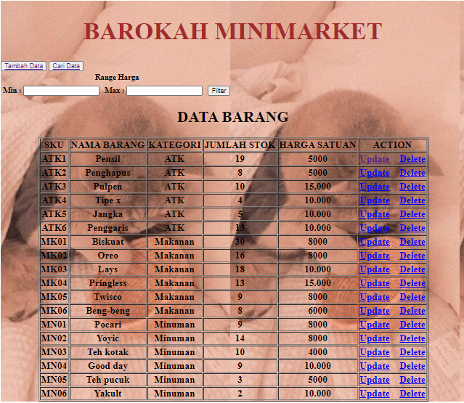

1. Proses Update Data

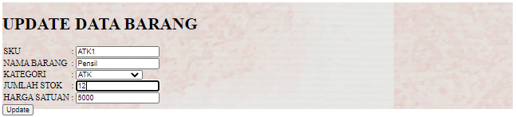

Outputnya :

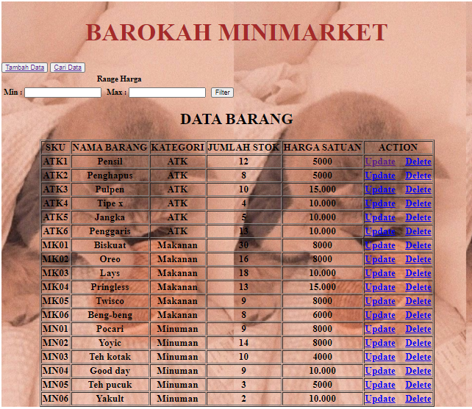

1. Delete data

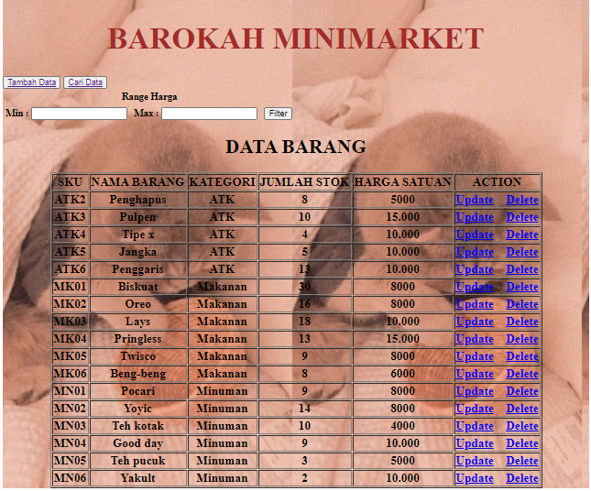

1. Proses Tambah Data

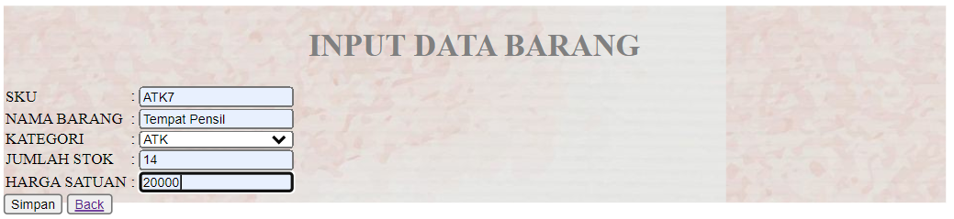

Output tambah data

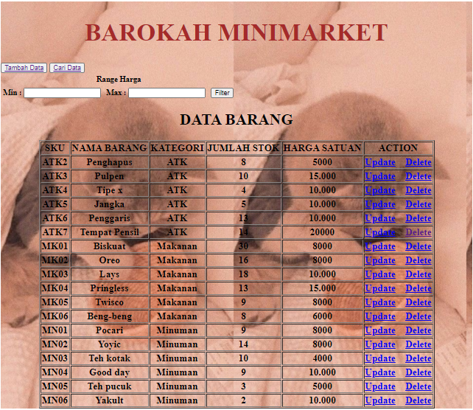

1. Tamplan Search Data

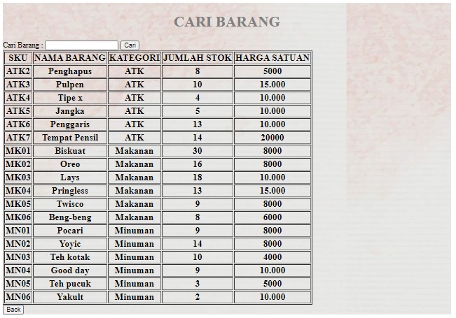

1. Proses cari data berdasarkan kategori(minuman)

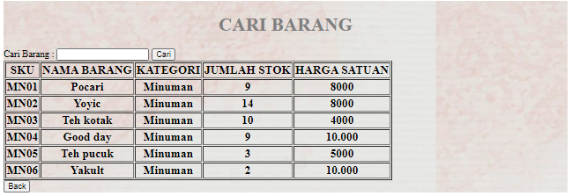

1. Proses cari data berdasarkan kategori(makanan)

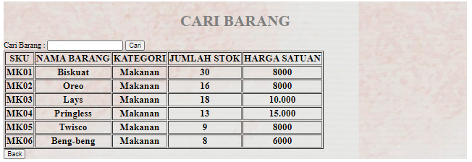

1. Proses cari data berdasarkan kategori(atk)

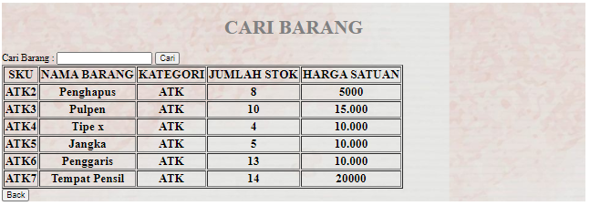

1. Salah satu proses cari data berdasarkan nama barang

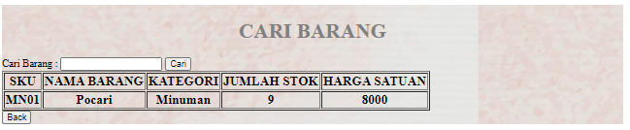

1. Salah satu proses cari data berdasarkan SKU

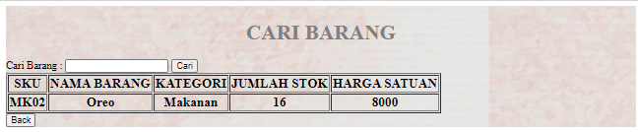

1. Salah satu filter range dari 3000 sampai 8000

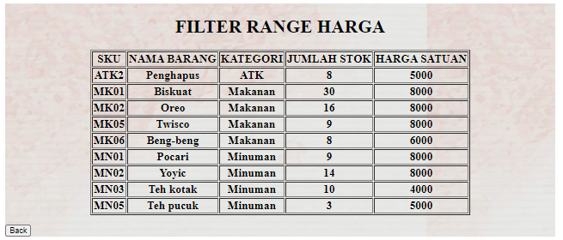

1. Tampilan database



1. Data didatabase

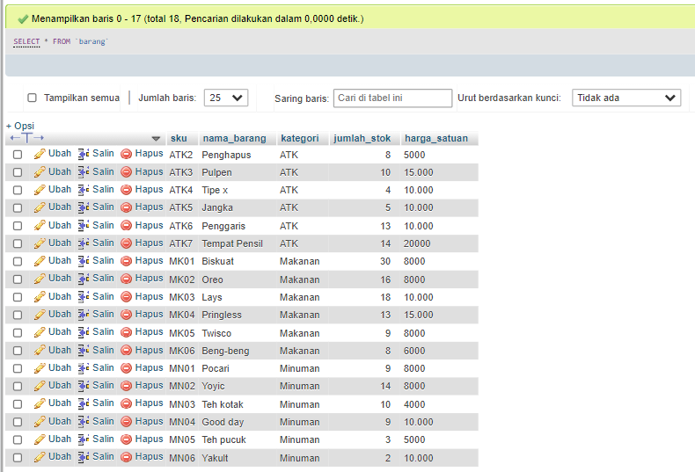

**Link github**

<https://github.com/Meikehardianti/Pemrograman-Web.git>